**PL/SQL**

Q1: Write a PL/SQL program to find the factorial of a given number

**Program**

declare

fact number:=1;

n number :=&n;

begin

for i in 2..n

loop

fact:=fact*n;

n:=n-1;

end loop;

dbms_output.put_line('Factorial is '||fact);

end;

/

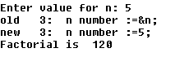

Q2: Write a PL/SQL program to check whether the given no is prime or not

**Program**

declare

n number;

i number;

temp number;

begin

n:=&n;

i:=2;

temp:=1;

for i in 2..n/2

loop

if mod(n,i) = 0

then

temp := 0;

exit;

end if;

end loop;

if temp = 1

then

dbms_output.put_line('is prime number');

else

dbms_output.put_line('is not prime number');

end if;

end;

/

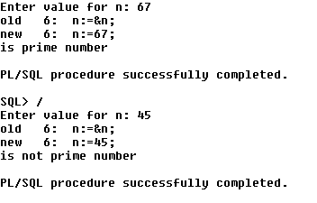

**Functions**

1. Write a PL/SQL program to Check whether a number is Armstrong or not using functions

create or replace function amt(n in number)

return number is

aa number;

s number;

r number;

begin

aa:=n;

s:=0;

while aa>0

loop

r:=aa mod 10;

s:=s+r*r*r;

aa:=trunc(aa/10);

end loop;

return s;

end;

/

declare

n number:=&n;

s number;

begin

s:=amt(n);

if s=n

then

dbms_output.put_line('Its a armstrong number!!');

else

dbms_output.put_line('Its not a armstrong number!!');

end if;

end;

/

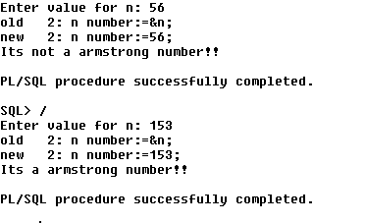

1. Create table that contains itemid,item_name & price of several items sold in a grocery shop, Using functions retrieve the item name & price from table when itemid is given as input.

**program**

create or replace function iitem(id varchar2)

return number as

p item.price%type;

c item.item_name%type;

begin

select item_name,price into c,p from item where itemid = id;

dbms_output.put_line('itemname :- ' ||c||' Price :- '||p);

return 0;

end;

/

declare

id varchar2(5);

begin

id:='&id';

dbms_output.put_line(iitem(id));

end;

/

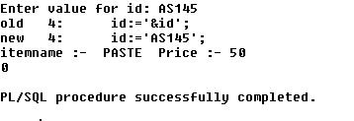

1. Write a PL/SQL function called POW that takes two numbers as argument and return the value of the first number raised to the power of the second .

**Program**

create or replace function pow2(a in number,b in number)

return number as

s number;

aa number;

bb number;

begin

aa:=a;

bb:=b;

s:=power(aa,bb);

return s;

end;

/

declare

a number:=&a;

b number:=&b;

s number;

begin

s:=pow2(a,b);

dbms_output.put_line('a pow b is:'||s);

end;

/

